# Media Analysis - ChatGPT is the ‘Netscape moment’ for artificial intelligence’ _ Arab News

## Short Summary

The article is about how ChatGPT has become a significant moment for artificial intelligence, similar to the impact of Netscape on the internet in the 1990s, and its potential applications and implications for various industries.

## Summary

Here are four bullet points summarizing the article:  
  
• ChatGPT's conversational interface has captured the popular imagination around artificial intelligence, similar to how Netscape made the World Wide Web accessible to millions in the 1990s.  
• Large Language Models (LLMs), such as those underlying ChatGPT, are trained on vast amounts of text using unsupervised learning and can generate responses, summaries, and text content based on prompts.  
• While LLMs have significant capabilities, they lack common sense, knowledge of the world, and the ability to reason, making them prone to hallucinations and generating false or misleading information.  
• The widespread proliferation of AI has the potential to ensure economic sustainability and prosperity in countries facing demographic challenges, such as Saudi Arabia, which is well-positioned to capture this opportunity due to its investments and programs in data and AI.

## Question 1

According to the text, the media frames the public discussion about ChatGPT as * A Netscape moment for artificial intelligence, implying a transformative and exciting development. * Comparing it to autocomplete on steroids, highlighting its ability to generate human-like responses. * Emphasizing its potential to create new value in various industries, such as law and consultancy. * Warning about its limitations, including the risk of hallucinations and misinformation. The text also uses metaphors like * Hallucinations to describe ChatGPT s tendency to generate false or misleading information. * Autocomplete on steroids to highlight its ability to generate human-like responses. * Comparing AI development to a new platform like the web, mobile, and social that will enable new applications.

## Question 2

According to the text * Widely covered Excitement generated by ChatGPT Its conversational interface capturing popular imagination around artificial intelligence Applications in various fields such as law and education Potential for generating high-quality content, contracts, and summaries * Ignored or mentioned only briefly Technical details of underlying technologies e.g. deep learning Debate on ethics and responsibility surrounding AI development

## Question 3

Saudi Arabia is mentioned as an example of a country that can benefit from leveraging AI, given its investments and programs in developing local AI capabilities through organizations such as the Saudi Data and AI Authority and companies like Aramco. The article suggests that the Kingdom can lead in the localization and extension of Large Language Models LLMs to Arabic languages and dialects, and use its knowledge in domains like energy to build foundation models that can be made available broadly.

## Question 4

The final message of the article is that Saudi entities should explore how AI can create new value in their respective fields and industries, highlighting the importance of embracing this technology to ensure future sustainability and prosperity.

## Sentiment

The sentiment is 3.0

## Entities

AI, ChatGPT, AI Authority, IBM, the Saudi Data, ANTHONY BUTLER, exempli ed, GPT, Anthony Butler, Aramco, Disclaimer Views, Arab News

## Highlights

#7cc867: 32

#fb5b89: 13

#c885da: 12

## Wordcloud for #7cc867 Highlights

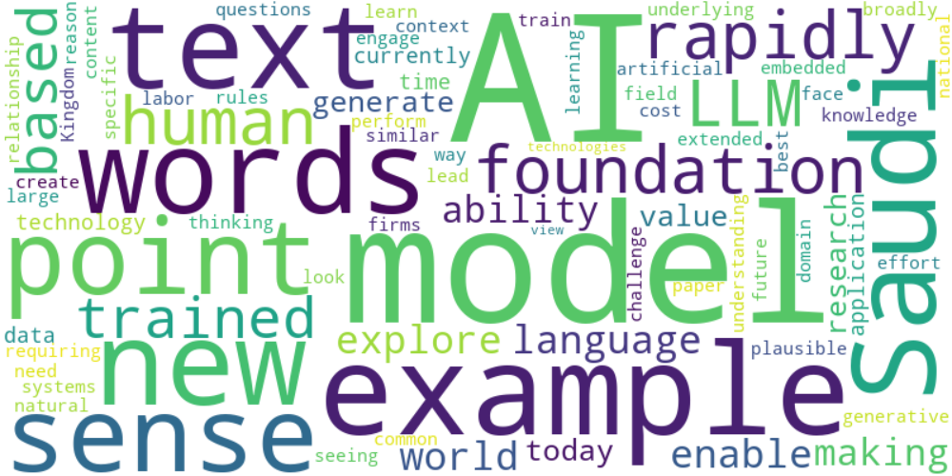

Top 10 words:

- AI: 13

- models: 8

- example: 6

- words: 5

- Saudi: 5

- text: 4

- point: 4

- sense: 4

- like: 4

- rapidly: 4

## Wordcloud for #fb5b89 Highlights

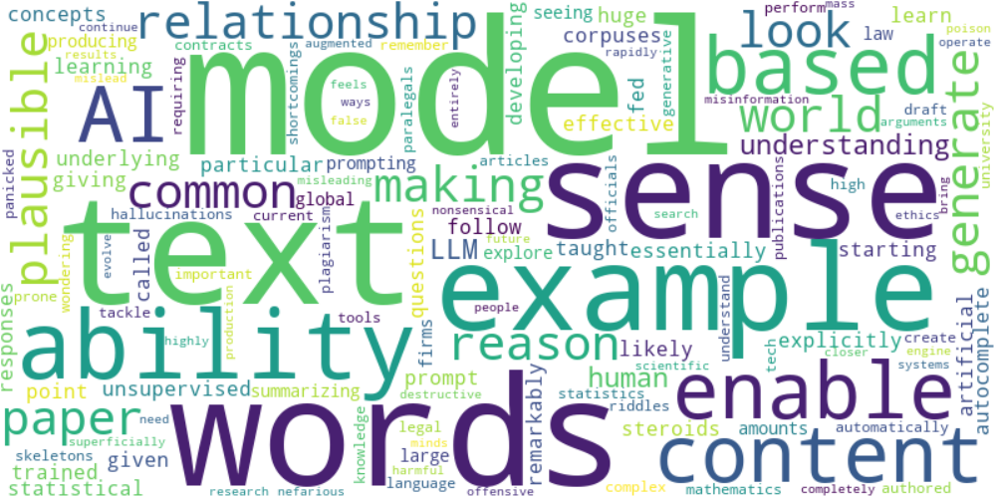

Top 10 words:

- models: 6

- words: 5

- text: 4

- sense: 4

- like: 3

- example: 3

- ability: 3

- model: 2

- content: 2

- based: 2

## Wordcloud for #c885da Highlights

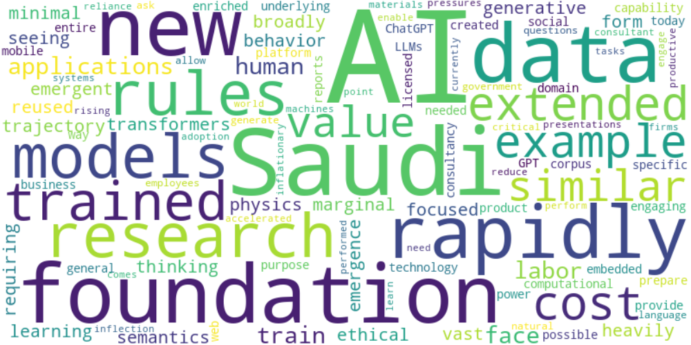

Top 10 words:

- AI: 9

- Saudi: 4

- new: 3

- rapidly: 3

- research: 2

- rules: 2

- foundation: 2

- trained: 2

- extended: 2

- example: 2